Output SnapShot

URL: http://localhost:8089/KeyWordSearchRestFulService/rest/SearchService/keywordSearch/int RedisModule_OnLoad(RedisModuleCtx *ctx, RedisModuleString **argv, int argc)

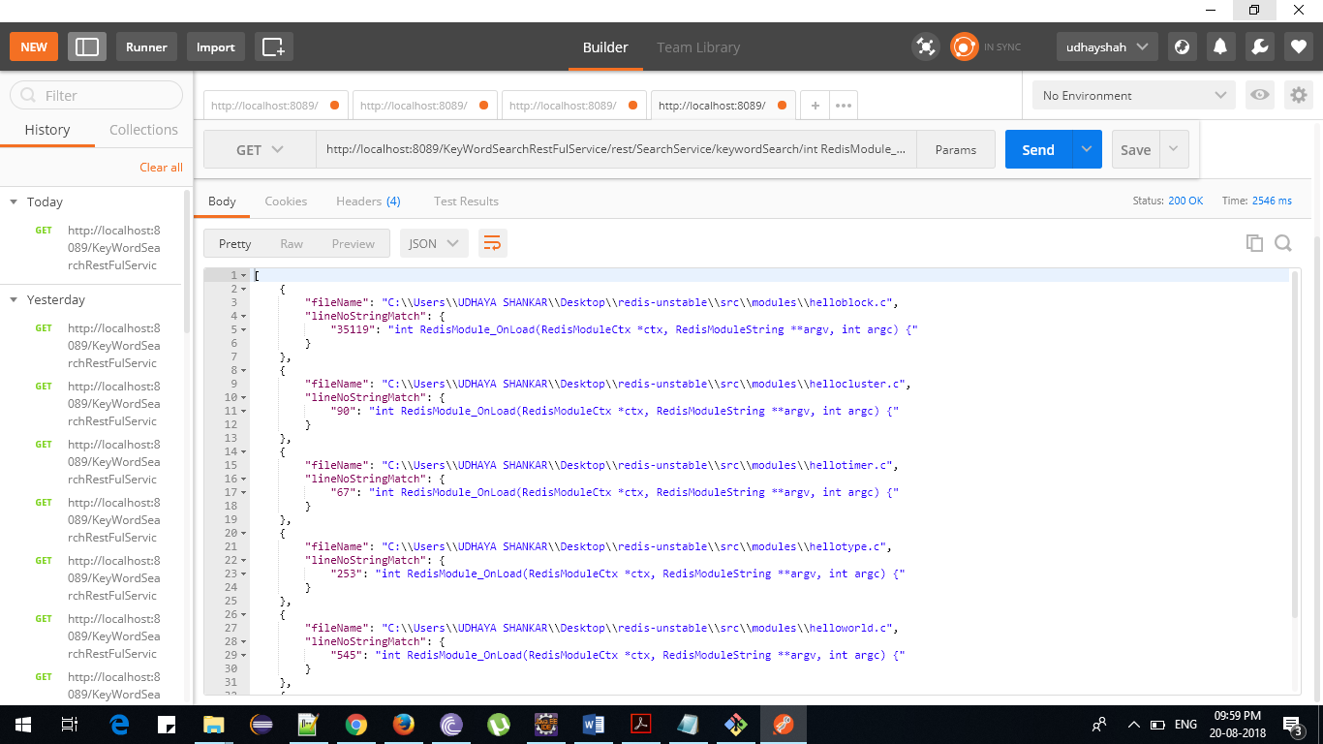

URL:

<http://localhost:8089/KeyWordSearchRestFulService/rest/SearchService/keywordSearch/redis>

